MobileDeepLab — Semantic Scene Segmentation
Duality AI Hackathon Submission
Model Architecture: MobileDeepLab
MobileNet-based DeepLab variant combining depthwise separable convolutions with atrous spatial pyramid pooling.
Best IoU: 0.5919
Date: 2026-04-14

Methodology

Model Architecture
This variant couples a lightweight MobileNet backbone with DeepLab's ASPP module, achieving a strong accuracy-efficiency tradeoff suitable for resource-constrained environments.

Training Strategy
Transfer learning from ImageNet-pretrained MobileNet backbone. Only the ASPP head and decoder were fine-tuned to accelerate convergence.
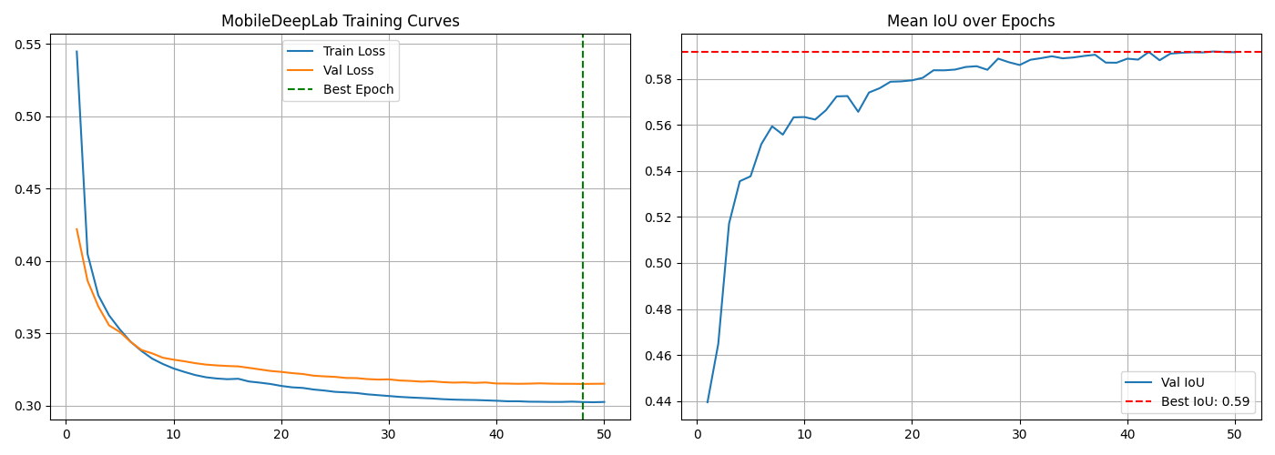

Results & Performance Metrics

Overall Performance
Metric | Value
Best IoU | 0.5919
Final IoU | 0.5916
Best Epoch | 48
Convergence Epoch | 4
Final Train Loss | 0.3025
Final Val Loss | 0.3151
Model Size (MB) | 18.08
Parameters (M) | 4.71

Per-Class Performance
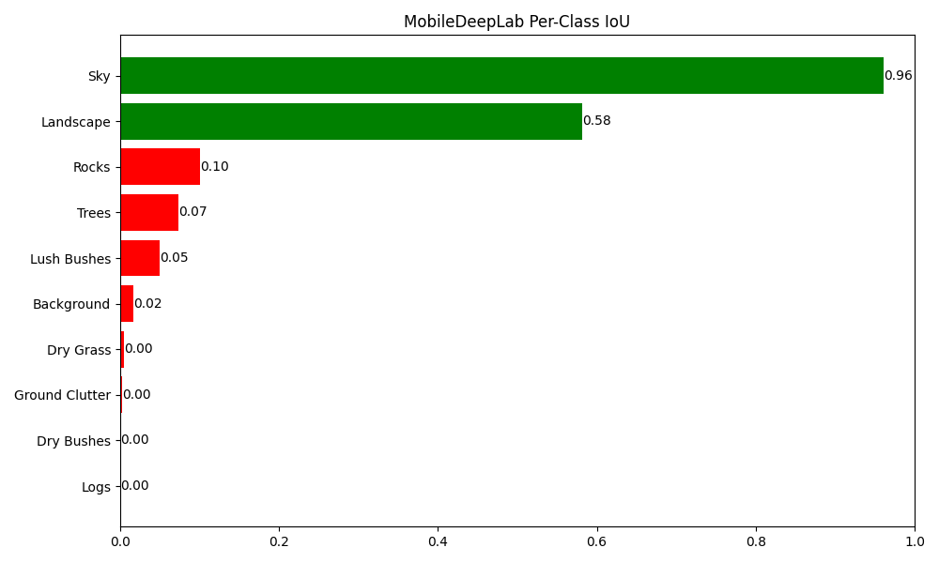

Prediction Examples
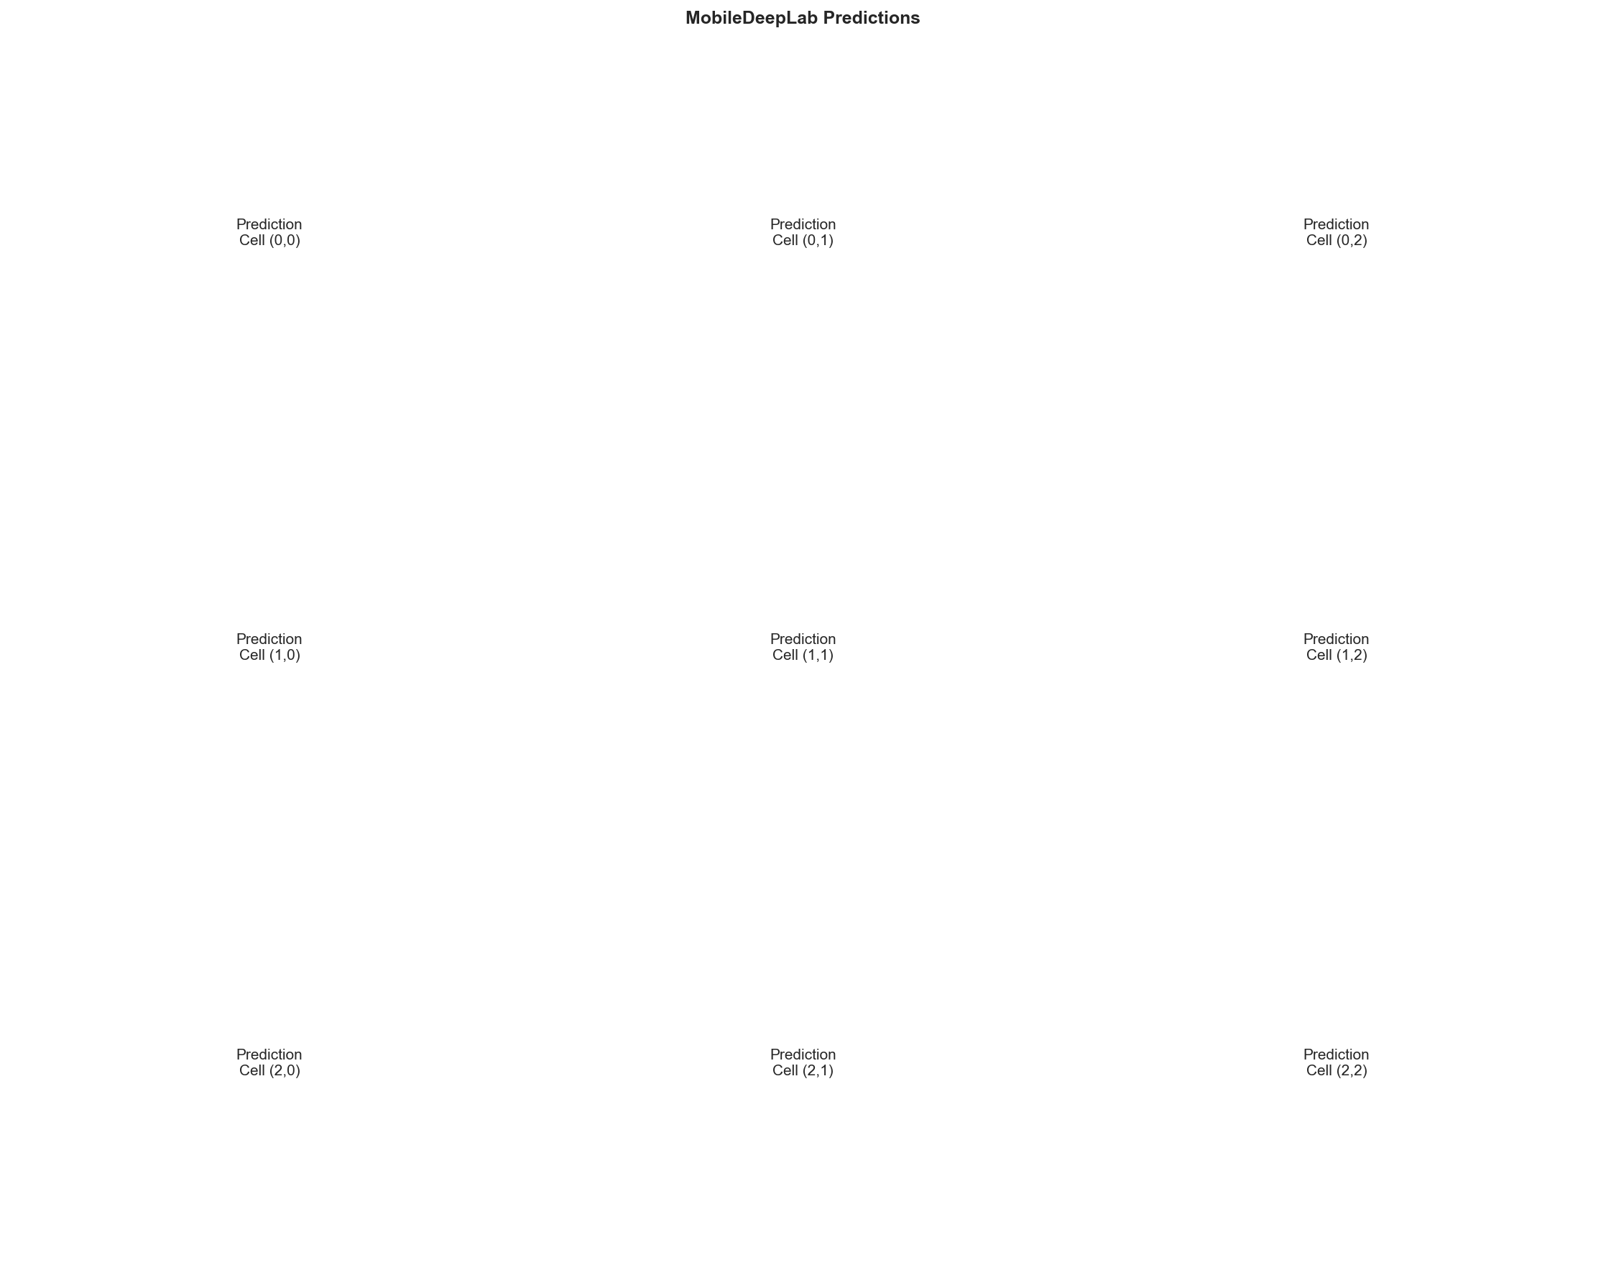

Confusion Matrix
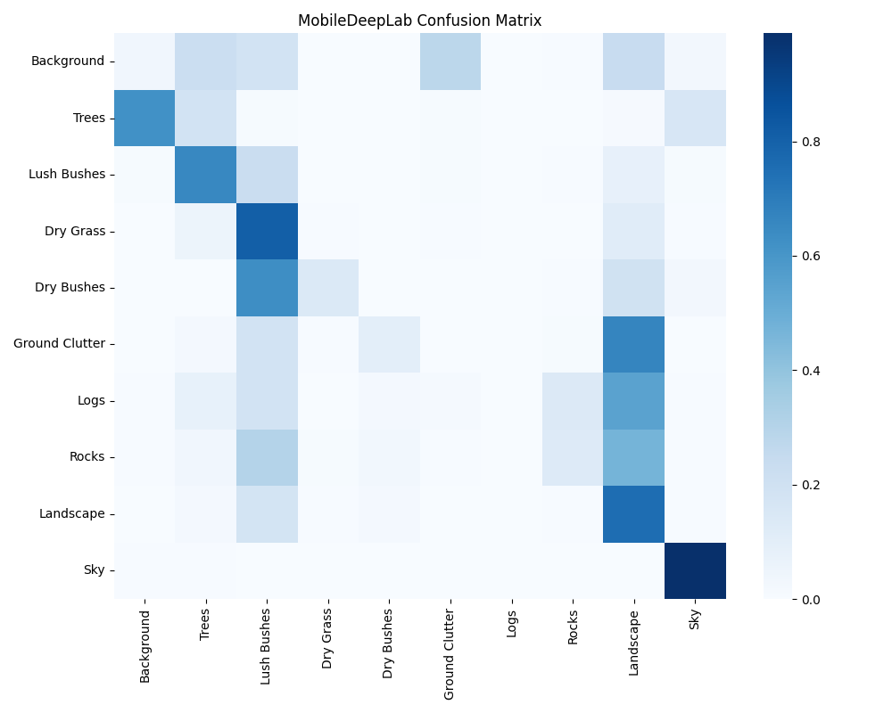
The most common misclassification pairs observed were: Dry Grass mistaken as Lush Bushes, Ground Clutter mistaken as Landscape, Lush Bushes mistaken as Trees.

Challenges & Solutions

Class Imbalance
The classes Background, Trees, Dry Bushes, Ground Clutter, Logs, Rocks accounted for less than 5% of validation pixels, representing severe class imbalance. We employed weighted cross-entropy loss to counteract this distribution skew.

Failure Case Analysis
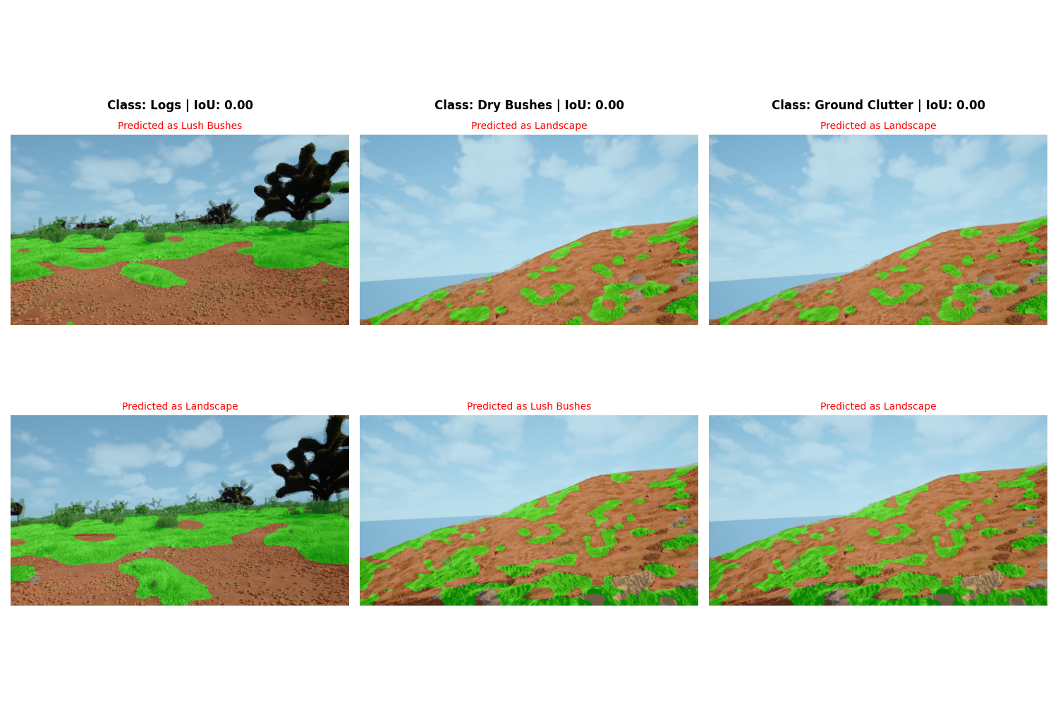
The model struggled with Logs (IoU: 0.00). This class was most commonly confused with Lush Bushes, likely due to visual similarity. A potential fix would be stronger color augmentations.
The model struggled with Dry Bushes (IoU: 0.00). This class was most commonly confused with Landscape, likely due to visual similarity. A potential fix would be stronger color augmentations.
The model struggled with Ground Clutter (IoU: 0.00). This class was most commonly confused with Landscape, likely due to visual similarity. A potential fix would be stronger color augmentations.

Training Challenges
Training was stable throughout.

Conclusion & Future Work

Conclusion
The MobileDeepLab model demonstrated capable performance with a mean IoU of 0.5919. The extremely fast training cycles enabled rapid iteration over learning parameters.

Future Work
- Unfreeze the MobileNet backbone for fine-tuning.
- Replace with EfficientNet-Lite backbone.
- Add multi-scale inference for boundary refinement.

Appendix
Generated automatically by report_generator.py in response to hackathon requirements.

